**FIND AND LOCATE**

which locate

locate <dir name>

locate <file name>

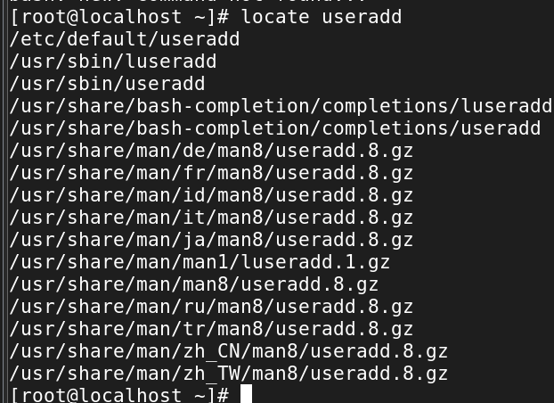

1. Find Files Using Name in Current Directory

# find . -name data.txt

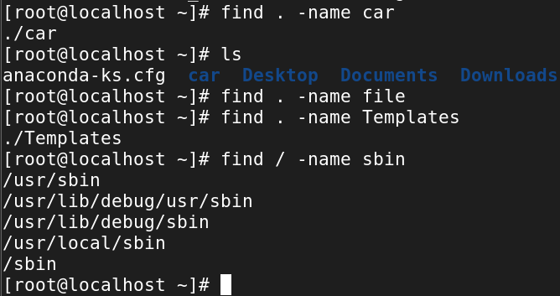

3. Find Files Using Name and Ignoring Case

find /home -iname data.txt

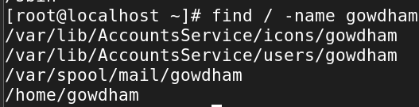

4. Find Directories Using Name

# find / -type d -name Data

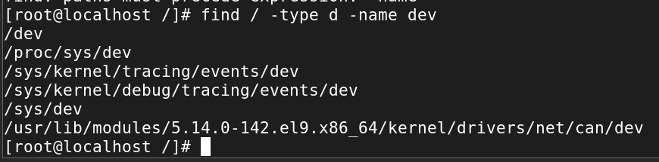

5. Find PHP Files Using Name

# find . -type f -name index.php

6. Find all PHP Files in the Directory

# find . -type f -name "*.php"

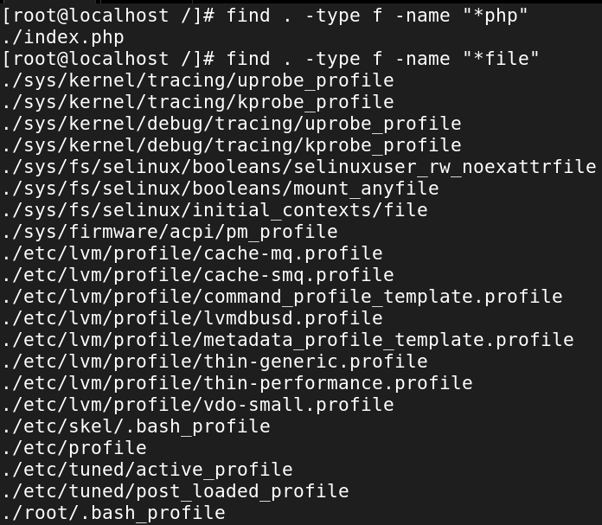

7. Find Files With 777 Permissions

# find . -type f -perm 0777

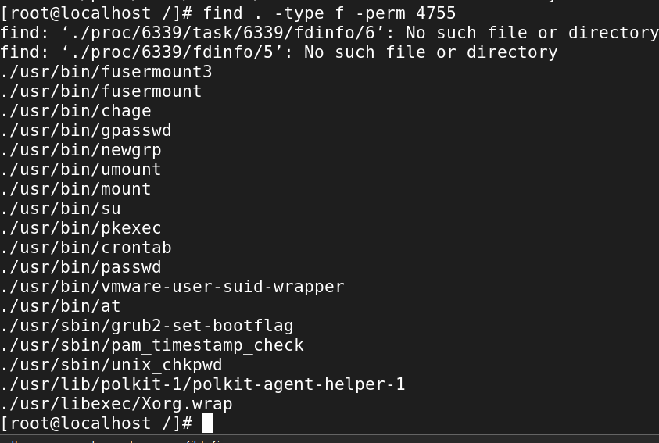

8. Find Files Without 777 Permissions

# find / -type f ! -perm 777

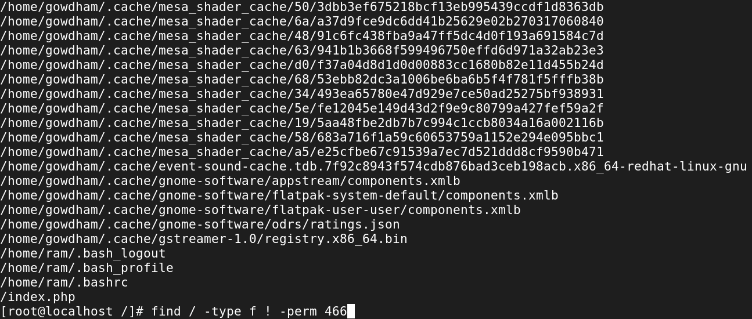

9. Find SGID Files with 644 Permissions

# find / -perm 2644

10. Find Sticky Bit Files with 551 Permissions

# find / -perm 1551

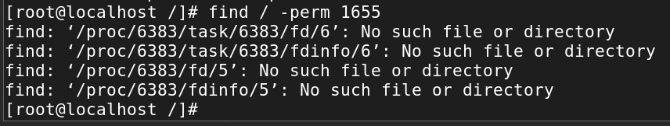

11. Find SUID Files

# find / -perm /u=s

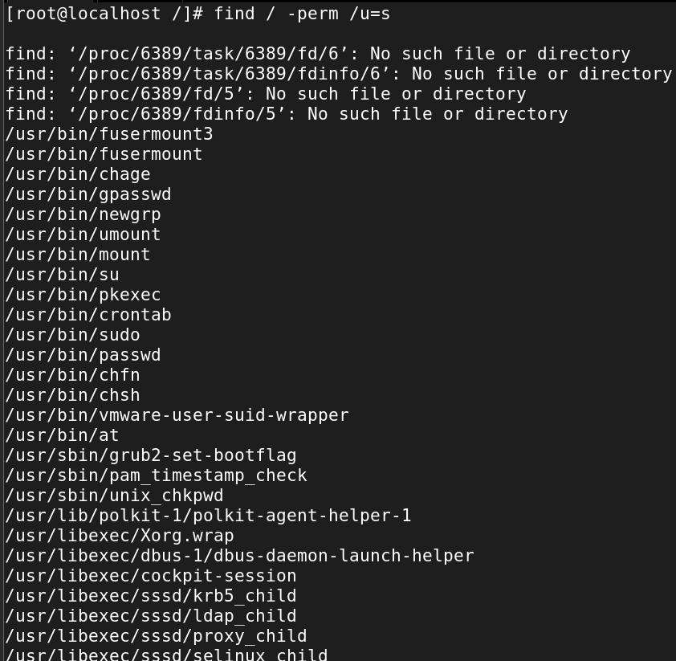

12. Find SGID Files

# find / -perm /g=s

13. Find Read-Only Files

# find / -perm /u=r

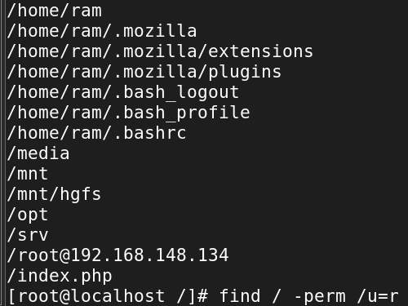

14. Find Executable Files

# find / -perm /a=x

15. Find Files with 777 Permissions and chmod to 644

# find / -type f -perm 0777 -print -exec chmod 644 {} \;

16. Find Directories with 777 Permissions and Chmod to 755

# find / -type d -perm 777 -print -exec chmod 755 {} \;

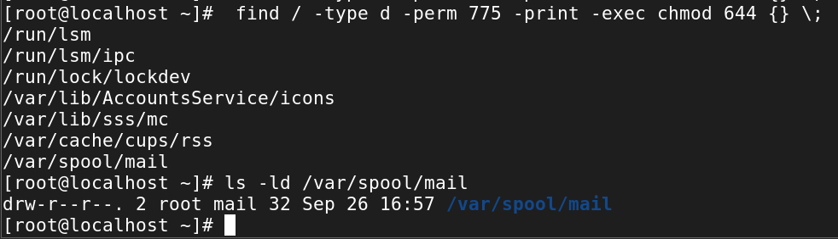

17. Find and remove single File

# find . -type f -name "tecmint.txt" -exec rm -f {} \;

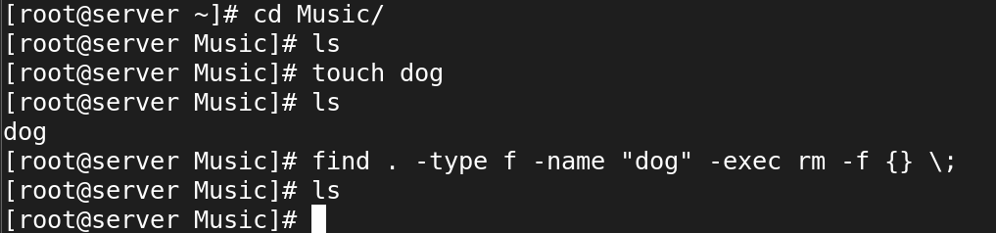

18. Find and remove Multiple File

# find . -type f -name "*.txt" -exec rm -f {} \; OR

# find . -type f -name "*.mp3" -exec rm -f {} \;

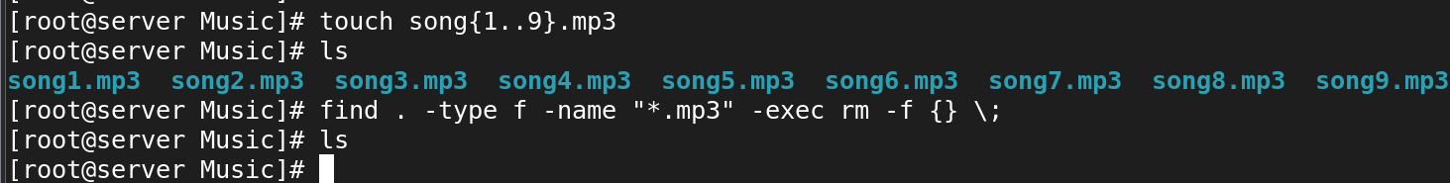

19. Find all Empty Files

# find . -type f -empty

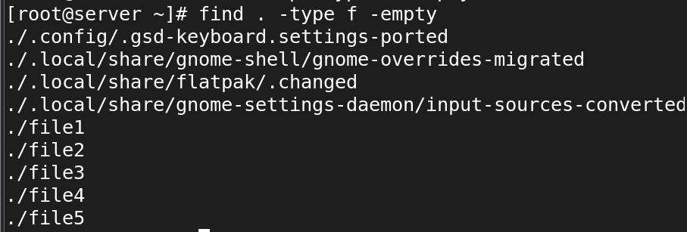

20. Find all Empty Directories

# find /tmp -type d -empty

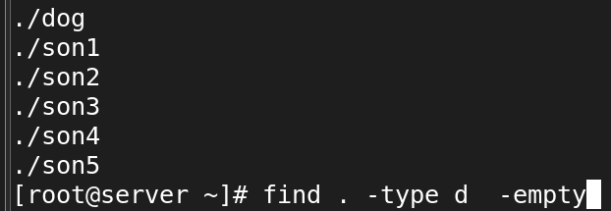

21. File all Hidden Files

# find . -type f -name ".*"

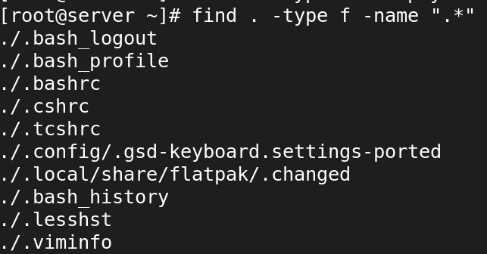

22. Find Single File Based on User

# find / -user root -name tecmint.txt

23. Find all Files Based on User

# find /home -user tecmint

24. Find all Files Based on Group

# find /home -group developer

25. Find Particular Files of User

# find /home -user tecmint -iname "*.txt"

26. Find Last 50 Days Modified Files

# find / -mtime 50

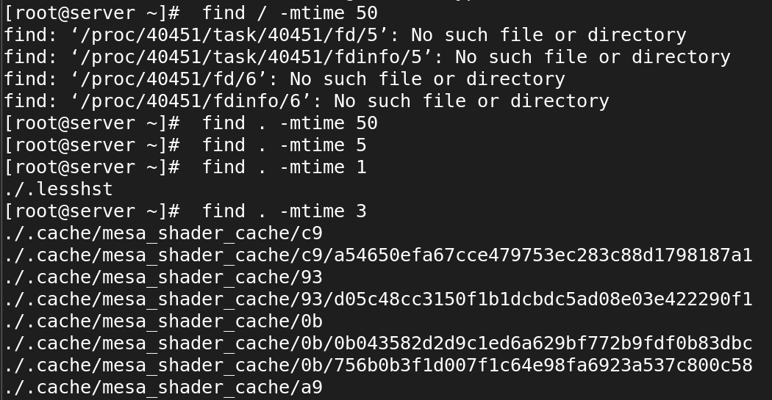

27. Find Last 50 Days Accessed Files

# find / -atime 50

28. Find Last 50-100 Days Modified Files

# find / -mtime +50 –mtime -100

29. Find Changed Files in Last 1 Hour

# find / -cmin -60

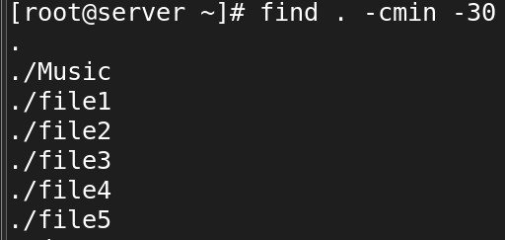

30. Find Modified Files in Last 1 Hour

# find / -mmin -60

31. Find Accessed Files in Last 1 Hour

# find / -amin -60

Part V – Find Files and Directories Based on Size

32. Find 50MB Files

# find / -size 50M

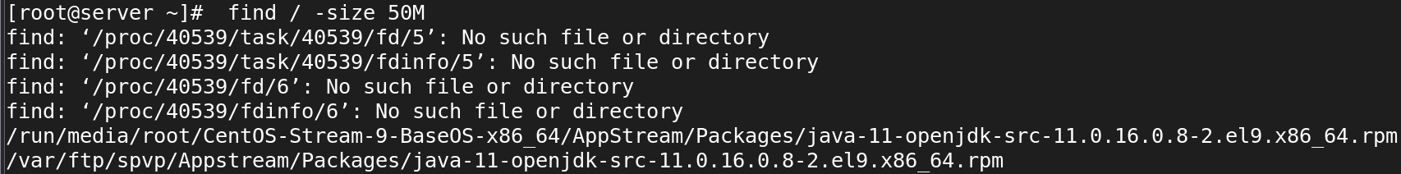

33. Find Size between 50MB – 100MB

# find / -size +50M -size -100M

34. Find and Delete 100MB Files

# find / -type f -size +100M -exec rm -f {} \;

35. Find Specific Files and Delete

# find / -type f -name *.mp3 -size +10M -exec rm {} \

**-type**

**-size**

**-user**

**-group**

**-perm**

**-delete**

**-exec**

**-print**

**-mtime**

**-mmin**

**-atime**

**-amin**

**-cmin**